Dear Travel Partner,
Please find the below package rate and suggested itinerary

03 nights /04 days

Package Rate: Rs. 11,150/- Per Pax (Quotation on 02 Pax ) on 01 double sharing room.

Hotel in Port Blair : Mount View Pristine/ Hill View/Hotel Vedant/Similar

Vehicle: Swift Dzire / Ertiga / Xylo / Scorpio / Tavera (a/c)
Meal Plan MAP: Breakfast Only

Note : The above rate is exclusive of all taxes@5%.
Suggested Itinerary :
03 NIGHTS 04 DAYS (PORT BLAIR: 03 NIGHTS )
Day 1 : Port Blair – City Tour
On arrival at Port Blair airport, our representative will receive and escort to the hotel. After check-in at the hotel and a little relax, we proceed to Carbyn’s Cove Beach & Cellular Jail. Evening enjoy the enthralling Light and Sound Show at Cellular Jail where the saga of the freedom struggle is brought alive. Overnight stay at Port Blair.
• Corbyn's Cove Beach
The coconut palm fringed beach, 3 kilometers away from town is ideal for swimming and sun-basking. Facilities like a hotel, restaurant, bar, changing room, and adventure water sports are available here. Historical remains like Japanese Bunkers can be seen on the way to this beach. Snake Island situated just across the beach is popular for scuba diving. The Restaurant & Beer Bar run by the Tourism department provides delightful cuisine at reasonable rates in a soothing ambiance on the beach.
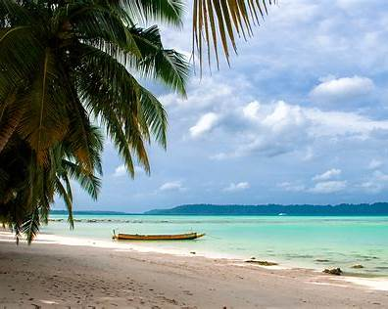
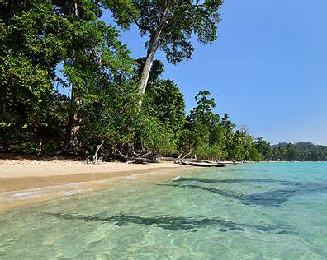
• Light & Sound Show
The Sound and Light show in the Cellular Jail narrates the saga of the Indian freedom struggle, brought alive through the sound and light effect of the brutal and barbaric atrocities piled on the freedom fighters deported to these islands and incarcerated in the small cells of this jail. This show is very popular among the tourists visiting these islands.
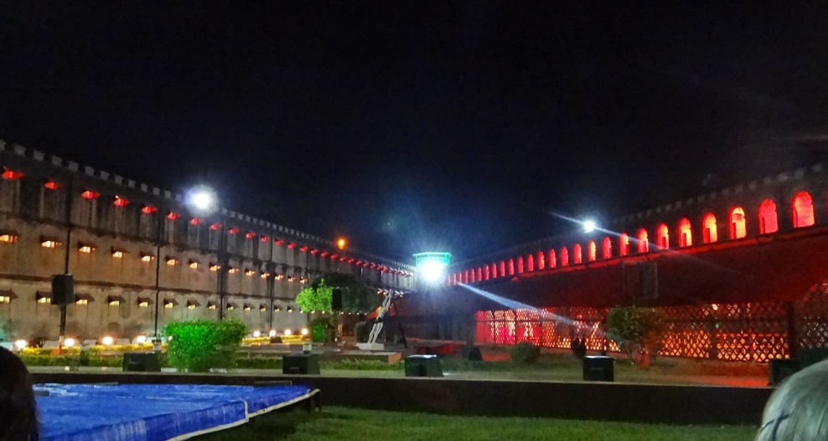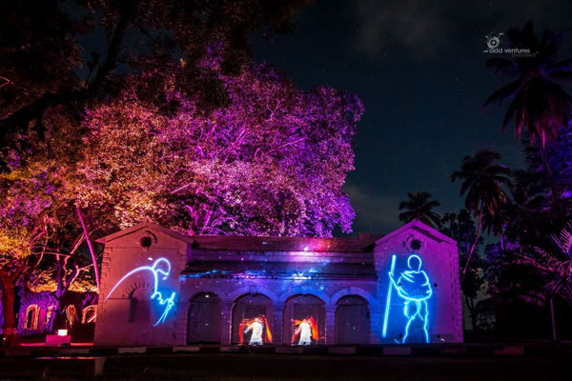

• Cellular Jail
mute witness to the most brutal and barbaric atrocities meted out to national freedom fighters, who were incarcerated in this jail. The jail, completed in the year 1906 acquired the name ‘Cellular' because it was entirely made up of individual cells for solitary confinement. It originally was a seven-block structure with three stories and a central tower acting as its fulcrum consisting of honeycomb-like corridors. This jail, now a place of pilgrimage for all freedom-loving people draws everyone down memory lane to the years of freedom struggle. The Jail Museum is open from 9:00 am to 12:00 noon and from 1:30 pm to 4:45 pm.
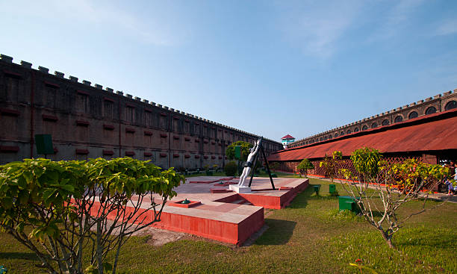
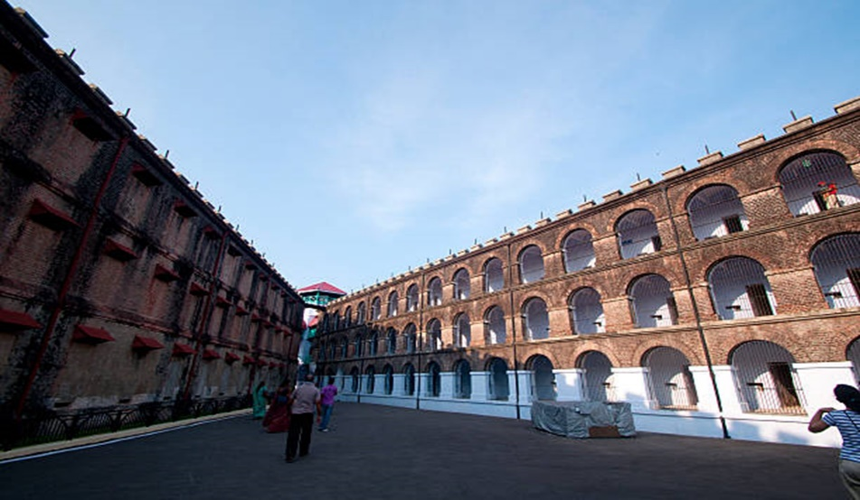

Day 2: Port Blair to Excursion to Coral island & Ross Island :
After Breakfast you will be escorted to Andaman Water Sports Complex to catch a ferry which will be your mate for the entire excursion to Ross Island and North Bay. Overnight stay at Port Blair.
• North Bay
It is also called “The GateWay to Port Blair”. This place is famous for its coral reefs, exotic verities’ of beautiful ornamental fishes and water sports activities. The breathtaking stretch of coral bed leaves you spellbound. North Bay is the foremost snorkeling point of Andaman. Apart from snorkeling and glass-bottom boat ride, scuba diving, underwater sea walk facility is also available at North Bay.
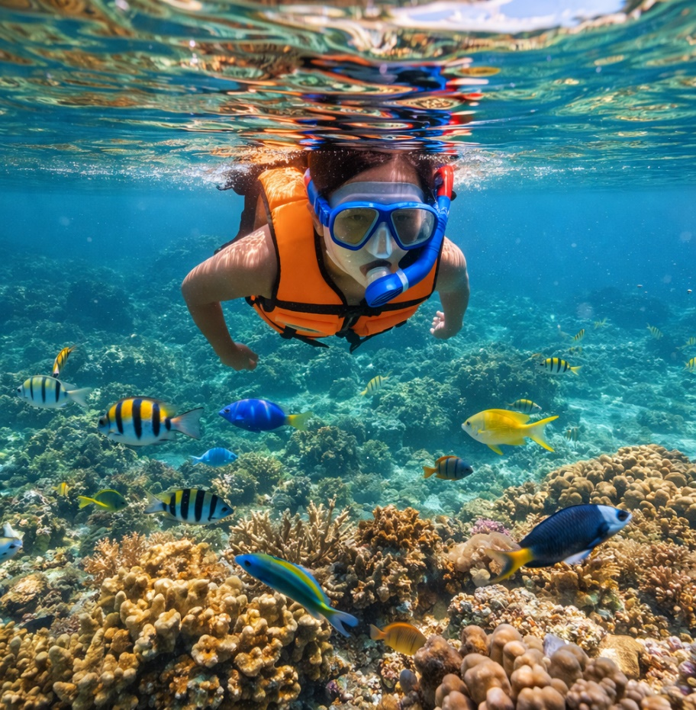
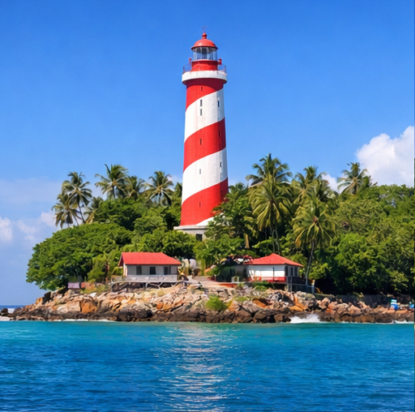

• Ross Island
It was the Capital of Port Blair during the British and Japanese regime, prior to India’s Independence. It was named after Sir Daniel Ross, a marine surveyor. It was nicknamed “The Paris of the East”. It is now under the supervision of the Indian Navy. This island is an ideal destination for nature walks amidst sylvan surroundings with deer’s, peacocks and exotic birds.
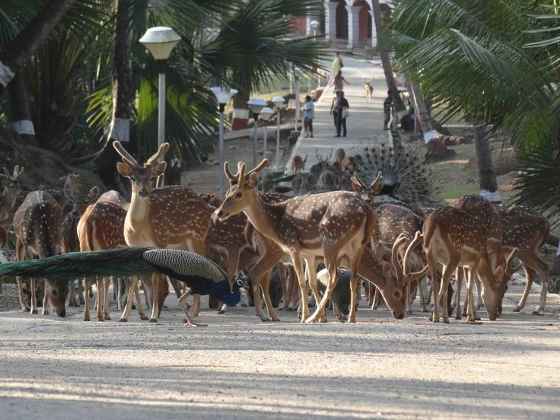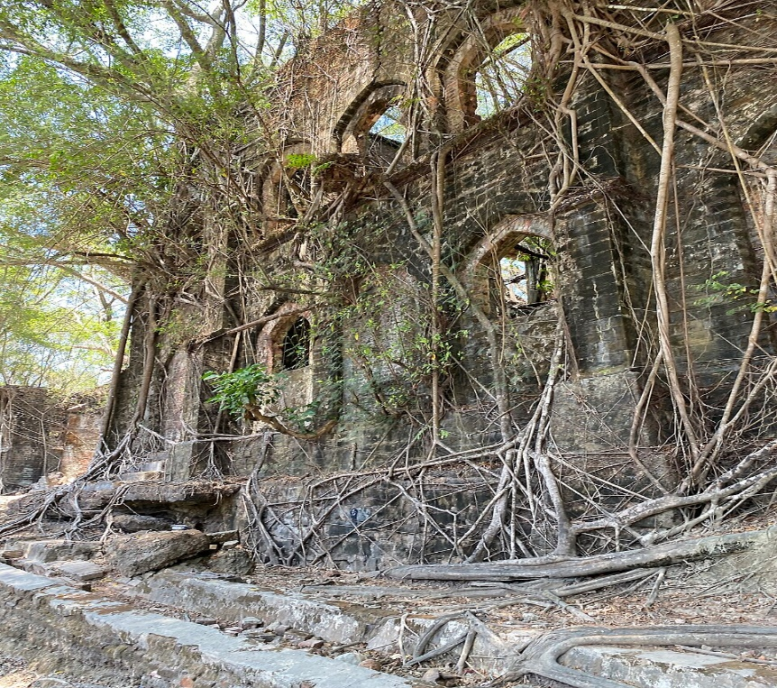

Day 03: Port Blair – Baratang Beach:-
Baratang is famous for its natural wonders; from impressive Limestone Caves and dense mangrove creeks. There are tidal swamp forests and small but fascinating Mud Volcanoes. It is the first gateway up north from the capital city, located between the Middle and South of Andaman.
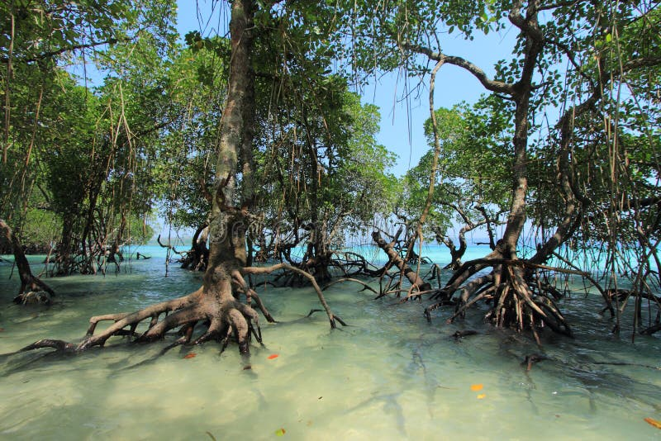
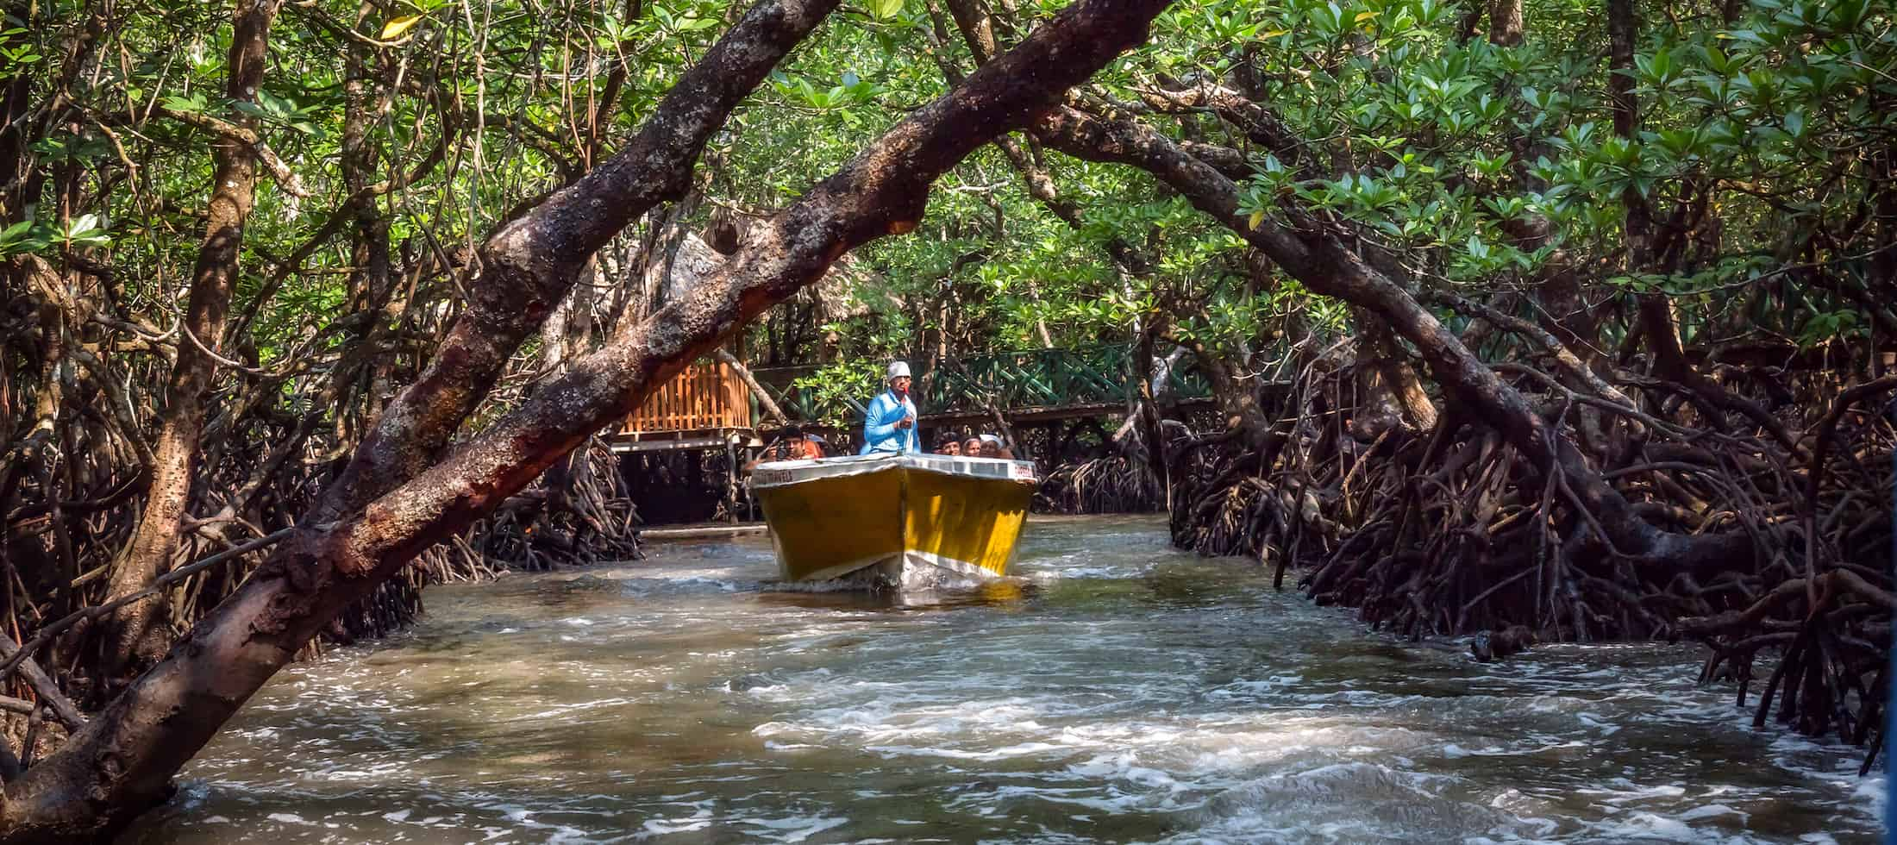
Day 04: Port Blair – Airport Dropping
Dropping to the airport with memories and terrific holiday at Andaman Islands.
Note: If your departure flight is a delay, the additional tour will be arranged on a direct payment basis.
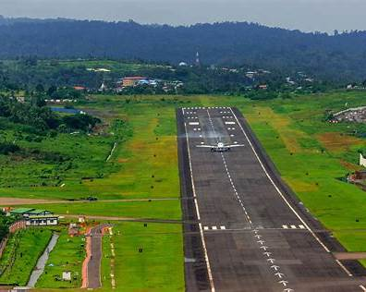
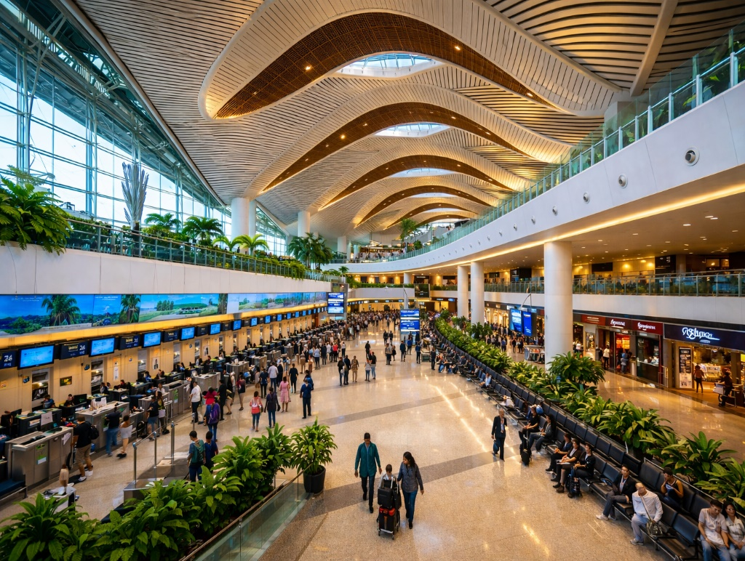

Dropping to the airport with memories and a terrific holiday at the Andaman Islands
Note: If your departure flight is delayed, the additional tour will be arranged on a direct payment basis.

Package Includes :
Accommodation on a double sharing basis at the above-mentioned hotels / similar in base category rooms.
Exclusive a/c vehicle sanitized every time before boarding for pick up and drop as per the itinerary (not at disposal).
Daily breakfast Only.
Airport pick up and drop by a/c vehicle.
Makruzz / Green Ocean Cruise / Sea Link / ITT Majestic (base category) for Neil & Havelock as per the availability.
Assistance at all arrival and departure points.
Entry permits | Entry tickets | Parking charges | Boat/ferry tickets wherever applicable.

Package Excludes :
Airfare / Ship's fare.
All kinds of personal expenses such as tips, laundry, telephone bills and beverages.
It does not include any meals unless and otherwise specifically mentioned.
Guide, Jolly ride & snorkeling charges.
Optional, suggested or unspecified activities.
Guide at Cellular jail will cost extra.
Camera fee (still or movie)
Additional usage of vehicles.
Any dispute regarding the child's age is to be settled directly with the hotels.
 GST (5%) if bill required.

Note :

 The above is just a quote, no rooms have been blocked. Rooms are subject to availability at the time of confirmation.
Since the Union Territory of Andaman and Nicobar is under the restricted area category, please carry a valid photo identity proof for all travelers issued by competent authorities.
Our representative will hold the placard outside the exit gate of the Airport.
Check-out time at most of the hotels in Port Blair / Havelock / Neil Island is 0900 hrs. Late check-out as per availability only, although guaranteed check-out is possible by paying 50% of the room charges.
Issues regarding child age to be settled with hotels directly.
We do not book any of our guests to Havelock / Neil in govt. ferry, until and unless there is an emergency or disruption, we may shift the guest to govt. ferry to Havelock & and Neil Island.

Important Travel Tips to protect yourself and others during Covid-19:
The use of a facemask is mandatory.
Maintain a distance of 6 feet (2 meters) between you and others as much as possible.
Keep hand sanitizer and use it on a regular basis.
Avoid touching your eyes, nose, and mouth.
All guests must mandatorily have the Aarogya Setu Mobile application installed and used frequently.
Use hand gloves whenever traveling by ferry/cruise or any crowded area.
Maintain hygiene standards.

